Australian Mammals
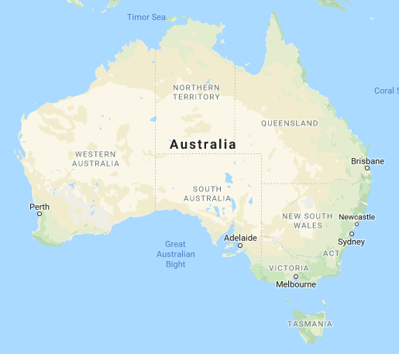

Australian Mammals
Your name here

Australian Mammals 1
THE DINGO 2
Habitat 2
Description 2
Eating 2
Characteristics 2
Caring for young 3
THE KANGAROO 3
Habitat 3
Description 3
Eating 3
Characteristics 3
Voice 4
THE ECHIDNA 5
Habitat 5
Description 5
Eating 5
Characteristics 5
Caring for young 5
Voice 6
THE KOALA 7
Habitat 7
Description 7
Eating 7
Characteristics 7
Caring for young 7
Voice 7
THE PLATYPUS 8
Habitat 8
Description 8
Eating 9
Characteristics 9
Looking after young 9
Voice 9
THE WOMBAT 10
Habitat 10
Description 10
Eating 10
Characteristics 10
Caring for young 10
Voice 11

THE DINGO

Habitat
The dingo is terrestrial and fights with other dingoes for their own territory. They often live in caves and in burrows. It is found in all areas of Australia but mainly inland of NSW and in South Australia.

Description
The dingo has a brown or orange colour coat .It is a fair bit stronger than the common domestic dog with strong hind legs with strong non-retractable claws. They have tall pointed ears with a pointed mouth and nose. They can grow to a size of 150 cm when they have their front paws off the ground.

Eating
The dingo eats all kinds of animals including wombats, echidnas, birds, possums, wild pigs, wallabies, rabbits and reptiles. Dingoes generally hunt for food at night.

Characteristics
The dingo is normally nocturnal but is seen commonly in daytime. They may often enter human tents and carry off items for kilometers.

Caring for young
Females come into season once a year (in winter) having 3-5 pups at a time. The female has the pups in late July or early August. The mother feeds the pups with milk while the male hunts for meat.

THE KANGAROO

Habitat
The kangaroo lives in open shrub and grassland, forests and agricultural land.
It can be found in NSW, South Australia, Victoria, Tasmania and Eastern Queensland.

Description
The eastern gray kangaroo has soft woolly fur it has large ears that are pointed, It’s face is a brownish gray colour and is very thick but short, It has very strong hind legs which allow it to jump long distances (9m) .On the end of it’s feet or paws are very strong claws. It may grow to 150 cm but much taller when standing up on reared toes. The female eastern gray is smaller and a lot lighter.

Eating
The eastern gray mainly feeds on herbs and grasses. Although it does not need water because it gets most its moisture from its food it will go to the main waterhole to drink after dark. It is also mainly nocturnal.

Characteristics
This kangaroo is mainly nocturnal. However, if it is a cold or wet day it may go out to feed. Groups are generally small with less than 10 in the group.

Caring for young
This kangaroo gives birth generally in the summer time. The Joey is born straight into the pouch where it will develop for around 10 months.

Voice
The kangaroo makes grunting, coughing and sucking noises.

THE ECHIDNA

Habitat
The echidna lives in hollow logs and inside hollow trees at the bottom. They may also live in rabbit and wombat burrows. The area surrounding their homes is sometimes sand dunes, forests, scrub land and also agricultural areas. Echidnas are found in all four states of South Eastern Australia, but generally throughout Australia.

Description
The short nosed echidna is found only in Australia and is about 35-53 cm long. It has short but strong legs with powerful claws on each paw. Its back is covered in long stiff spines mixed with coarse hairs that protect against predators. It also has a long sticky tongue for catching small insects.

Eating
The echidna eats mostly ants, termites and other small insects. The echidna also swallows a lot of dirt accidentally.

Characteristics
The echidna is most active during early morning and late evening. When it feels threatened it grips to its surroundings strongly.

Caring for young
The female lays one or two eggs after a period of 9-27 days. These eggs are put into a pouch for a time of 10-12 days .The young echidna is carried around in a pouch until it can walk.

Voice
The echidna makes snuffling noises through its nostrils. These noises are possibly used for communication.
They make high-pitched howls and whining sounds to communicate.
THE KOALA

Habitat
The koala lives high up in eucalyptus trees in woodlands and in open forests in the fork of two branches. The are mainly found NSW, Victoria, and Queensland although they were introduced to South Australia, Tasmania and Western Australia.

Description
The koala is a medium sized marsupial. It grows to 60-83 cm long. It has round furry ears and a stout body that is covered by thick grayish and white fur. It has short legs but they are very strong for climbing tree .At the ends of each leg are strong claws for gripping objects.

Eating
The koala feeds on selected types of leaves from eucalyptus trees. It also sometimes feeds on certain types of flowers.

Characteristics
The female koala is mainly nocturnal but the male is not. The male will often travel long distances to find an uninhabited tree.

Caring for young
The female koala bares only one young at a time. The young koala is kept in the pouch for 6 months. After this time it is carried around on its mothers back until it is half grown.

Voice
The koala makes pig like grunts and loud prolonged whimpering wailing cries when in distress.

THE PLATYPUS

Habitat
The platypus lives near well-watered riverbanks and lakes it will build burrows often 5-20 metres long sometimes beneath roots of large trees not far from the water. The platypus does not live near salt-water lakes.
They are found throughout NSW, Victoria, and in the South Eastern parts of Tasmania and South Australia.

Description
The platypus has a long duck lie bill with nostrils at the end of it .It doesn’t have any external ears . it also has webbed feet witch help it swim and claws on the end of them .They help them dig and sift through stones on the river bed .It also has amazing waterproof fur.

Eating
The platypus sifts through the riverbed looking for invertebrates, molluscs, crustaceans and earthworms.

Characteristics
The platypus is mostly nocturnal but sometimes searches for food in the daytime in colder climates.

Looking after young
The platypus lays two eggs , that are incubated for two weeks and then suckled for four two five months.

Voice
The platypus makes growling and snorting noises.

THE WOMBAT

Habitat
The wombat lives open forest and woodland making its home in burrows, It also lives in hollow logs when in rocky country. The wombat ranges from Queensland to southeastern South Australia. Also lives in Tasmania and on Flinders Island.

Description
The wombat is a quite sturdy animal .It has dark or greyish brown, It has a short tail that is covered by the fur. It has short rounded ears and its face is very thick and quite flat .It has short legs that aren’t noticeably strong. They have paws without well-defined pads. It grows to a height of 68 cm and weighs up to 36 kg.

Eating
The wombat feeds on certain grasses, vegetation, and roots, leaves and types of fungi. Normally eats at night because it is nocturnal.

Characteristics
The wombat is largely nocturnal but is seen walking during the day. They are also very slow. Young also follow instinctively on their mother’s heels.

Caring for young
The wombat generally has one young in its pouch at a time from May to December. They are usually on their own once the next summer comes around. The young wombat follows at its mothers heels instinctively

Voice
The wombat makes whizzing, grunting and also growling noises when in distress to communicate with other wombats

